Kadijatu Bah

October 21, 2018

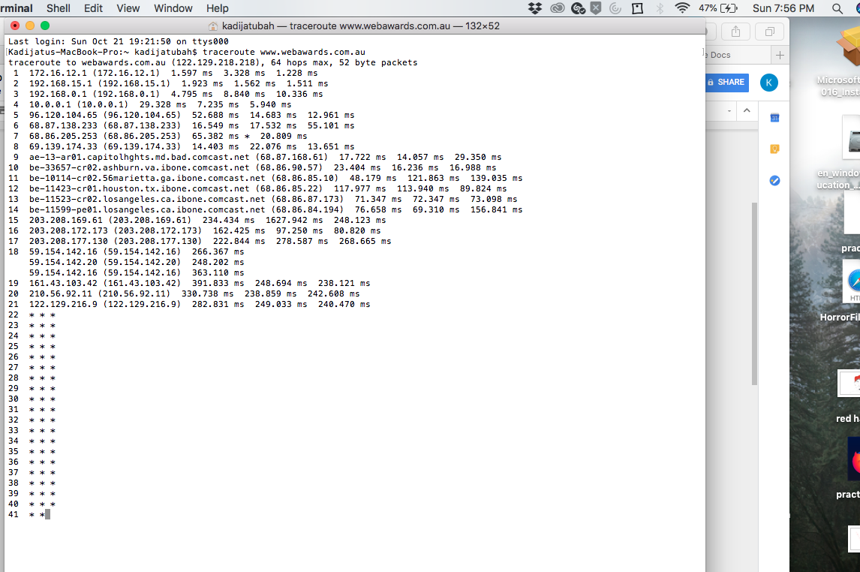

* **Questions:**
  1. What is your computers IP address? (This is not included in your traceroute results). Take a screenshot of your computers IP address.

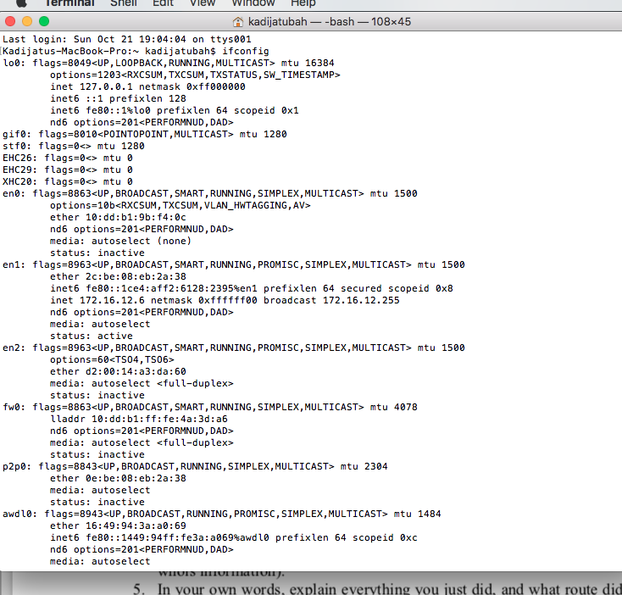

**The IP address is 172.16.12.6.**

* 1. With reference to private/public IP addresses. What type of IP address is the first IP from your traceroute result.
* **The first IP address on this list is a private IP address. The first IP address is 172.16.12.1 and the range of private IP’s it falls under is 172.16.0.0 to 172.31.255.255.**



* 1. With reference to private/public IP addresses. What type of IP address is the second IP from your traceroute result.
* **The second IP address on this list is a private IP address. The second IP address is 192.168.15.1 and the range of private IP’s it falls under is 192.168.0.0 to 192.168.255.255.**



* 1. In a tabular format (use table example below), and in sequential order. Indicate the location of each IP address (include state for US states) and the organization that owns the IP address. (Use https://www.ultratools.com/tools/ipWhoisLookup to look up IP address whois information).

|  |  |  |  |
| --- | --- | --- | --- |
| Hop Count | IP address | Organization (IP Owner) | Location (US state)/Country |
| 1 | 172.16.12.1 | Internet assigned numbers authority (IANA) | Los Angeles, California |
| 2 | 192.168.15.1 | Internet assigned numbers authority (IANA) | Los Angeles, California |
| 3 | 192.168.0.1 | Internet assigned numbers authority (IANA) | Los Angeles, California |
| 4 | 10.0.0.1 | Internet assigned numbers authority (IANA) | Los Angeles, California |
| 5 | 96.120.104.65 | Comcast IP Services, L.L.C. | Mt Laurel, New Jersey |
| 6 | 68.87.138.233 | Comcast IP Services, L.L.C. | Mt Laurel, New Jersey |
| 7 | 68.86.205.253 | Comcast Cable Communications, Inc. | Mt Laurel, New Jersey |
| 8 | 69.139.174.33 | Comcast Cable Communications, Inc. | Cherry Hill, New Jersey |
| 9 | 68.87.168.61 | Comcast Cable Communications, Inc. | Mt Laurel, New Jersey |
| 10 | 68.86.90.57 | Comcast Cable Communications, Inc. | Mt Laurel, New Jersey |
| 11 | 68.86.85.10 | Comcast Cable Communications, Inc. | Mt Laurel, New Jersey |
| 12 | 68.86.85.22 | Comcast Cable Communications, Inc. | Mt Laurel, New Jersey |
| 13 | 68.86.87.173 | Comcast Cable Communications, Inc. | Mt Laurel, New Jersey |
| 14 | 68.86.84.194 | Comcast Cable Communications, Inc. | Mt Laurel, New Jersey |
| 15 | 203.208.169.61 | Singapore Telecommunications (SINGTEL Internet Exchange) | Singapore |
| 16 | 203.208.172.173 | Singapore Telecommunications Limited | Singapore |
| 17 | 203.208.177.130 | Singapore Telecommunications Limited | Singapore |
| 18 | 59.154.142.16 / 59.154.142.20 | SingTel Optus Pty Ltd | Australia |
| 19 | 161.43.103.42 | SingTel Optus Pty Ltd | Australia |
| 20 | 210.56.92.11 | EscapeNet | Australia |
| 21 | 122.129.216.9 | Web Prophets Pty Ltd | Australia |

5. In your own words, explain everything you just did, and what route did your packet took from source to destination. How many US states did your packet go through? How many countries if any?

* **My packet started off on it’s journey in los angeles, California starting off using private IP addresses. When the IP addresses switched to public IP’s after the service provider (comcast) translated them, the packet went through New jersey both Mt Laurel and Cherry Hill. After leaving New Jersey, the packet went to Singapore then made its way to the destination in Australia. My packet went through 2 US states, both California and New Jersey. Overall the packet went through 3 countries including the US.**

**WhoIs screenshots:**

